3GPP TSG-RAN WG4 Meeting #119 R4-2605930
Dalian, CHINA, May 18 - 22, 2026
Agenda item: 8.10.4
Source: Xiaomi
Title: View on 6G Sensing coexistence
Document for: Discussion

1. Introduction
Based on the latest approved RAN working group level SID on 6G Radio [RP-252912], RAN4 study on sensing including RF, coexistence, testability, with the detailed objective provided as:
- Sensing – Studies to be based on use cases and associated requirements, as defined in [TR38.914]
- PHY functions and procedures for sensing technology (e.g., waveform. reference signals, measurement feedback, etc…) [RAN1, RAN4]
- Evaluate sensing performance and if necessary, extend channel modelling, for the selected use cases [RAN1]
- Aspects of integration with communication services [RAN1]
- higher layer procedures and protocol aspects [RAN2]
- RAN4 aspects of sensing including RF, coexistence, and testability in coordination with other WGs [RAN4]
Note: RAN1 identify detailed requirements, if triggered by TSG RAN

This contribution will analyze the key points of 6G Sensing coexistence research.
- Discussion

Methodology
Compared with RAN1 system-level simulations, RAN4 coexistence simulations adopt a number of simplifications, such as simplified propagation and channel models, simplified measurement procedures, etc. These simplifications are mainly adopted because these factors do not affect the calculation of interference between the two systems, and the unnecessary procedures are removed to improve simulation efficiency.
For ISAC-specific procedures, RAN4 also needs to consider whether they have a direct relationship with interference calculation, and simplify such unnecessary procedures in coexistence studies to improve efficiency.
The core objective of 3GPP NR Sensing coexistence study is to evaluate the end-to-end service-level QoS of sensing under interference. All mandatory standardized sensing performance metrics (localization accuracy, velocity accuracy, missed detection probability, and two types of false alarm probability) are target-level outputs directly defined by Level D measurement, which fully matches the core research scope without any need for intermediate physical layer data from Level A/B/C.
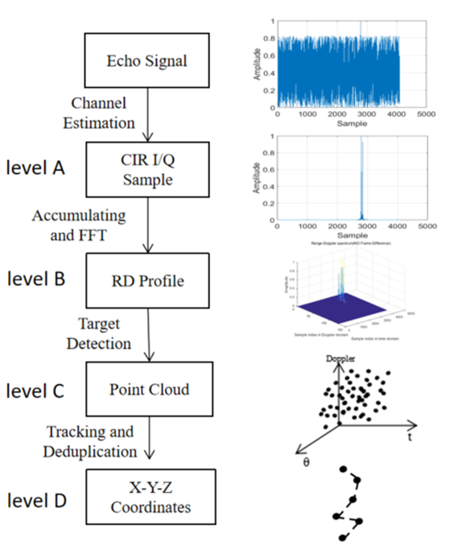
Observation 1: All mandatory standardized sensing performance metrics are target-level outputs directly defined by Level D measurement.

Full link simulation (Level A→B→C→D) requires end-to-end physical layer processing modeling, with exponentially growing complexity and workload as the number of cells, antennas and targets increases, which cannot support the large-scale multi-cell deployment and massive parameter sweep required by coexistence study. Level D abstraction eliminates all intermediate physical layer modeling, reduces simulation complexity from O (NRB​×N antenna​×N symbol​) to O(N target​), cuts down per-drop runtime by 2–3 orders of magnitude, and enables sufficient independent simulation drops to meet RAN4’s statistical confidence requirements within a feasible timeline.

Observation 2: Level D simulation complexity is much lower than the other three levels.
All interference in coexistence scenarios ultimately manifests as the degradation of sensing receiver instantaneous SINR, and 3GPP has standardized the normative mapping model from SINR to target-level sensing performance. Level D simulation directly quantifies the impact of interference on sensing service performance based on this standardized model, eliminating result discrepancies caused by different vendors’ underlying algorithm implementations, and ensuring the repeatability and comparability of simulation results — a mandatory requirement for 3GPP standardization research.
Proposal 1: RAN4 can consider simulate Level D for the coexistence study.

Target coupling loss model
In sensing systems, the coupling loss represents the total two-way propagation loss from the sensing transmitter to the target and back to the sensing receiver. This is fundamentally different from the one-way link budget used in communication coexistence studies (Clause 5.2.5).
For TRP monostatic sensing, the coupling loss is defined as:
$$L_{coupling} = PL(d_{Tx}-target) + PL(d_{target}-Rx) + 20*log10(c / (4*pi*f_{c})) - 10*log10(sigma_{RCS},A) + SF_{1} + SF_{2} [dB]$$
where:
- PL(d) is the path loss for each leg, using the propagation model defined in Table 5.2.2.1-1 for the corresponding scenario (e.g., UMa-AV reuses the UMa path loss model)
- $d_{Tx-target}$ and $d_{target-Rx}$ are the 3D distances from transmitter to target and target to receiver, respectively
- $f_{c}$ is the carrier frequency in Hz
- $sigma_{RCS,A}$ is the mean RCS value (Component A) defined in TR 38.901 Section 7.9
- $SF_{1}$ and $SF_{2}$ are the shadow fading values for each leg, independently generated
For TRP bistatic sensing, the same formula applies, but $d_{Tx-target}$ and $d_{target-Rx}$ are generally different, and a bistatic RCS correction factor may need to be applied depending on the bistatic angle.

Sensing SINR model
The sensing SINR differs from the communication SINR (Clause 5.2.5) in that the received signal is the target echo rather than a direct communication signal. The sensing SINR is defined as:
$$SINR = P_{tx} - L_{coupling} + G_{tx} + G_{rx} - (P_{noise} + P_{interference}) [dB]$$
where:
- $P_{tx}$ is the sensing transmitter power (same as BS Tx power defined in FFS)
- $L_{coupling}$ is the target coupling loss defined in 1.1
- $G_{tx}$ and $G_{rx}$ are the transmit and receive antenna gains, respectively
- $P_{noise} = -174 + 10*log10(BW) + NF [dBm]$, where NF is the noise figure defined in FFS
- $P_{interference}$ is the total interference power from aggressor systems
The interference power from each aggressor source is calculated following the same ACIR model as defined in Clause 5.2.6:
$$P_{intf,i} = P_{tx,intf} - PL_{intf}(d_{intf}) + G_{intf} - ACIR + 10*log10(rho_{TF}) [dBm]$$
where $ACIR = \frac{1}{\left(\frac{1}{ACLR}+\frac{1}{ACS}\right)}$ , and $rho_{TF}$ is the time-frequency overlap ratio between the sensing resource and the aggressor resource. The total interference power is obtained by linear summation:
$$P_{interference} = 10*log10(\sum_{i}{{10}^{P_{intf},\frac{i}{10}}} ) [dBm]$$
To account for the processing gain from coherent integration in the sensing signal processing chain (e.g., 2D-FFT over subcarriers and symbols), an effective SINR is defined as:
$$SINR_{eff} = SINR + 10*log10(N_{subcarrier} * N_{symbol}) [dB]$$
where$N_{subcarrier}$ is the number of subcarriers within the sensing bandwidth and $N_{symbol}$ is the number of OFDM symbols within the coherent processing interval (CPI).

Conditional Detection Probability Pd​(x) under Constant SNR:
The detection probability is defined as the probability that the test statistic exceeds the threshold when a target is present:
$$Pd​\left(x\right)=P\left(T>γ​H_{1}​,x\right)=\int_{γ}^{∞​}{f_{T∣H_{1}}}​​(t∣x)dt$$
Substituting the threshold $γ=-σn2​ln(Pfa​)$ and solving the integral yields the standard closed-form expression of detection probability under constant RCS:
$$Pd​(x)=Q1​(2x​,-2ln(Pfa​)​)$$
- where Q1​(⋅,⋅) denotes the first-order Marcum Q-function, a general function widely adopted in radar and sensing fields for calculating the detection probability of non-fluctuating targets.
- H1​: Target echo plus noise.
Observation 3: Conditional Detection Probability can be calculated based on SINR.

False alarm probability model
In sensing systems, the false alarm probability is determined by the CFAR (Constant False Alarm Rate) detection mechanism. Under the assumption that the interference is wideband and noise-like (e.g., OFDM communication signals), the interference primarily raises the noise floor perceived by the CFAR detector.
For a Cell-Averaging CFAR (CA-CFAR) with $N_{ref}$reference cells, the design false alarm probability is:
$$P_{fa,design} = alpha^{-\left(N_{ref}- 1\right)}$$
where alpha is the threshold scaling factor.
When interference is present, the CFAR noise estimate is elevated, which raises the detection threshold and modifies the actual false alarm probability. For wideband noise-like interference uniformly distributed across the sensing bandwidth:
$P_{fa,actual} = P_{fa,design} * {\left(\frac{P_{noise}}{P_{noise} + P_{interference}}\right)}^{N_{ref} - 1}$
This model indicates that wideband interference tends to reduce the false alarm probability (by raising the detection threshold), but simultaneously reduces the detection probability. The joint impact on $P_{d}$ and $P_{fa}$ should be evaluated together in the coexistence analysis.
Note: For structured interference (e.g., another sensing signal with distinct delay-Doppler characteristics), additional false alarm peaks may appear in the range-Doppler map, requiring a separate analysis beyond the noise floor elevation model.
Observation 4: False alarm probability can be calculated in the Level D simulation.

Positioning and velocity accuracy model
The estimation accuracy for range, angle, and velocity is modelled using the Cramer-Rao Lower Bound (CRLB) as the noise-limited baseline, augmented by a multipath correction term derived from TR 38.901 small-scale fading parameters.
- CRLB-based accuracy bounds
The CRLB provides the theoretical lower bound on the variance of any unbiased estimator. For sensing parameter estimation:
- Range estimation CRLB:
$$sigma_{R}^{CRLB} = c / (2*pi*BW * sqrt(2*SINR_{eff}*N_{eff})) [m]$$
- Horizontal angle estimation CRLB:
$$sigma_{theta}^{CRLB}= lambda / (2*pi*d_{array,h} * sqrt(2*SINR_{eff}*N_{eff})) [rad]$$
- Vertical angle estimation CRLB:
$$sigma_{phi}^{CRLB} = lambda / (2*pi*d_{array,v} * sqrt(2*SINR_{eff}*N_{eff})) [rad]$$
- Velocity estimation CRLB:
$$sigma_{v}^{CRLB} = lambda / (4*pi*T_{obs} * sqrt(2*SINR_{eff}*N_{symbol})) [m/s]$$
where $N_{eff}$ is the effective number of independent samples, lambda is the wavelength, $d_{array,h}$ and $d_{array,v}$ are the horizontal and vertical antenna array apertures, and $T_{obs}$ is the observation time.

Sensing parameter estimation (range, angle, velocity) suffers from two error sources: noise and multipath. Noise error is determined by SINR with established theory (CRLB). Multipath error, however, is directly governed by the channel's Delay Spread (DS), Angle Spread (ASA/ZSA), and Doppler Spread — since these parameters characterize how the target echo is "smeared" across delay, angle, and Doppler domains. When multipath spread exceeds the estimation resolution, the estimator cannot distinguish target from multipath, resulting in systematic bias.
- Covers both error sources simultaneously: CRLB addresses noise error; small-scale parameters address multipath error — together they provide a complete error bound
- Physically meaningful: Error in the multipath-limited region scales with channel spread, not just SINR
- Aligned with 3GPP standards: TR 38.901 §7.9.4 defines target channel parameters specifically for sensing, which can be directly used
Combined estimation error:
$$σ_{metric}​={\left(σ_{metricCRLB​}\right)}^{2}+{\left(k⋅spread\right)}^{2​}$$
where k is a calibration factor, and spread corresponds to DS (range), ASA (horizontal angle), ZSA (vertical angle), or Doppler spread (velocity).

Proposal 2: RAN4 can discuss to introduce small-scale parameters to simulate the sensing estimation error during coexistence study as below:

Multipath correction using TR 38.901 small-scale parameters
The CRLB captures only noise-limited accuracy. In multipath environments, the actual estimation error is dominated by multipath-induced bias and ambiguity when the channel spread exceeds the estimation resolution. The TR 38.901 small-scale fading parameters (Section 7.5) provide the necessary information to model this multipath contribution.
The combined estimation error is modelled as:
$$sigma_{metric} = sqrt({\left(sigma_{metric}^{CRLB}\right)}^{2} + {\left(sigma_{metric}^{multipath}\right)}^{2})$$
The multipath error terms are derived from TR 38.901 channel parameters as follows:
Table 1: Multipath error terms and corresponding TR 38.901 parameters
Metric | Multipath error term | TR 38.901 parameter | Physical interpretation
Range ($sigma_{R}$) | $$k_{R} * DS *\frac{c}{2}$$ | DS (Delay Spread) | Multipath delay causes range ambiguity
Horiz. angle (sigma_theta) | $$k_{theta} * ASA$$ | ASA (Azimuth Spread of Arrival) | Multipath angles cause horizontal ambiguity
Vert. angle (sigma_phi) | $$k_{phi} * ZSA$$ | ZSA (Zenith Spread of Arrival) | Multipath angles cause vertical ambiguity
Velocity (sigma_v) | $$k_{v} * f_{DS} *\frac{lambda}{2}$$ | $f_{DS}$ (Doppler Spread) | Doppler spread causes velocity ambiguity
where $k_{R}, k_{theta}, k_{phi}, k_{v}$ are multipath correction factors that depend on the sensing algorithm and the ratio of channel spread to estimation resolution. These factors are calibrated once per scenario using a limited set of link-level simulations (see Clause X.3.4).
The positioning accuracy in the horizontal and vertical planes is then derived from the range and angle errors:
$$sigma_{H} = sqrt(sigma_{R}^{2} + {\left(R * sigma_{theta}\right)}^{2}) [m]$$
$$sigma_{V} = sqrt(sigma_{R}^{2} + {\left(R * sigma_{phi}\right)}^{2}) [m]$$
where R is the true range from the sensing node to the target. At short range, the range error dominates; at long range, the angle error (amplified by R) dominates.

Applicability of TR 38.901 fast fading parameters
The TR 38.901 Section 7.5 provides the following fast fading parameters that are directly applicable to the sensing accuracy models defined above:
Table 2: Applicability of TR 38.901 fast fading parameters for sensing metric computation
TR 38.901 parameter | Section reference | Applied to metric | Role in computation
DS (Delay Spread) | 7.9.4 (target channel) | Range accuracy | Multipath correction for range estimation error
ASA (Azimuth Spread of Arrival) | 7.9.4 (target channel) | Horizontal positioning | Multipath correction for azimuth angle estimation error
ZSA (Zenith Spread of Arrival) | 7.9.4 (target channel) | Vertical positioning | Multipath correction for elevation angle estimation error
ASD (Azimuth Spread of Departure) | 7.9.4 (target channel) | Tx beamforming gain | Affects effective transmit gain towards target
ZSD (Zenith Spread of Departure) | 7.9.4 (target channel) | Tx beamforming gain | Affects effective transmit gain towards target
$N_{cl}$ (Number of clusters) | 7.9.4 (target channel) | $P_{d}$ (Swerling selection) | Determines RCS fluctuation model type
$N_{ray}$ (Rays per cluster) | 7.9.4 (target channel) | $P_{d}$ (Swerling selection) | Determines RCS fluctuation model type
RCS Component B | 7.9 | $P_{d}$ (RCS fluctuation) | Directly models RCS amplitude variability
Doppler spread (target channel) | 7.5 | Velocity accuracy | Multipath correction for velocity estimation error
The small-scale parameters (DS, ASA, ZSA, ASD, ZSD) follow log-normal distributions with scenario-dependent mean and standard deviation values specified in TR 38.901 Table 7.5-6. These distributions can be directly sampled in the Level D simulation to generate per-drop channel spread values for the multipath correction terms.

Proposal 3: RAN4 can consider the following Level D based Sensing Coexistence Simulation Methodology.

Level D based Sensing Coexistence Simulation Methodology
This sub-clause defines the Level D simulation methodology for evaluating the impact of interference on ISAC sensing performance metrics. The methodology extends the communication coexistence simulation approach defined in Clause 5.3 by incorporating sensing-specific models from Clause X.2 and TR 38.901 fast fading parameters.
The overall methodology is illustrated in Figure 1.
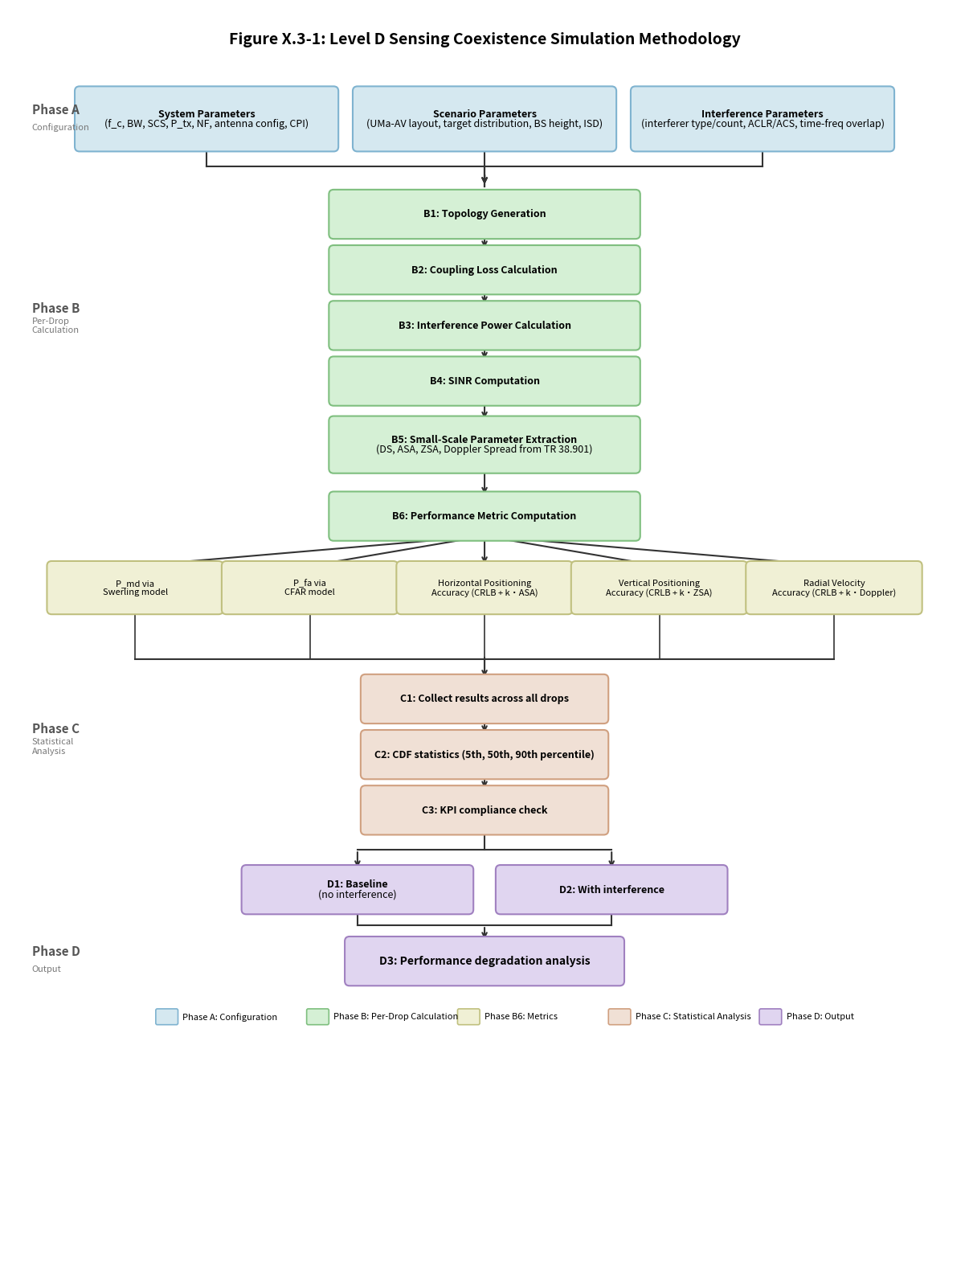
Figure 1: Level D sensing coexistence simulation methodology
a) Per-drop calculation phase
The following steps are executed for each Monte Carlo drop. The total number of drops is 1000 per simulation run.
Step 1: Topology generation
- Drop $N_{target}$ targets uniformly within each sector of the center site.
- For each target, sample the height from a uniform distribution over [25 m, 300 m].
- For each target, sample the horizontal speed from a uniform distribution over [0, 180] km/h.
- Record the true position (x, y, z) and velocity ($v_{x}, v_{y}, v_{z}$) of each target.
- Ensure minimum 3D distance between any target and any BS is at least 10 m, and between any pair of targets is at least 10 m.
Step 2: Coupling loss calculation
- For each target-sensing node pair, calculate the 3D distances$d_{Tx-target}$ and $d_{target-Rx}$.
- Determine LOS/NLOS condition using the LOS probability model from TR 38.901 Section 7.4.2.
- Calculate the path loss PL(d) for each leg using the UMa path loss model
- Generate independent shadow fading values $SF_{1} and SF_{2}$ from log-normal distributions.
- Compute the coupling loss L_coupling per the formula.
- Select the best N = 4 Tx-Rx pairs with the smallest coupling loss for each target.
Step 3: Interference power calculation
- For each interferer, calculate the 3D distance $d_{intf}$ from the interferer to the victim sensing receiver.
- Calculate the interference path loss$PL_{intf}\left(d_{intf}\right)$ using the same propagation model.
- Calculate the antenna gain $G_{intf}$ from the interferer towards the victim receiver.
- Determine the ACIR value based on the configured ACLR and ACS.
- Calculate the time-frequency overlap ratio $rho_{TF}$ between the sensing resource and the interferer resource.
- Compute the interference power contribution:$P_{intf,i }= P_{tx,intf} - PL_{intf} + G_{intf} - ACIR + 10*log10(rho_{TF})$.
- Aggregate all interferers: $P_{interference} = 10*log10\left(sum_{i}{10}^{P_{intf},\frac{i}{10}}\right)$.
Step 4: SINR computation
- Calculate the target echo power: $P_{signal} = P_{tx} - L_{coupling} + G_{tx} + G_{rx}$.
- Calculate the noise power: $P_{noise} = -174 + 10*log10(BW) + NF$.
- Calculate the total noise-plus-interference: $P_{total} = 10*log10({10}^{\frac{P_{noise}}{10}} + {10}^{\frac{P_{interference}}{10}})$.
- Compute the sensing SINR: $SINR = P_{signal} - P_{total} [dB]$.
- Compute the coherent integration gain: $G_{coherent} = 10*log10(N_{subcarrier} * N_{symbol})$.
- Compute the effective SINR:$SINR_{eff} = SINR + G_{coherent}\left[dB\right]$.
Step 5: Small-scale parameter extraction
The TR 38.901 fast fading parameters are required for the multipath correction of estimation accuracy metrics. The small-scale parameters can be sampled from their log-normal distributions defined in TR 38.901 Table 7.5-6. The mean and standard deviation values are scenario-dependent (e.g., UMa-AV). Each drop independently generates a set of small-scale parameters.
Step 6: Performance metric computation
For each target, the following five performance metrics are computed using the models
Statistical analysis phase
After completing all Monte Carlo drops, the following statistical analysis is performed:
Result collection
Collect all per-drop, per-target metric values into vectors:
Table 3: Collected metric data structures
Metric | Data structure | Dimension
$$P_{md}$$ | Per-target missed detection probability | $$N_{drops} x N_{targets}$$
$$P_{fa}\left(Type 1\right)$$ | Per-drop false alarm (no target drops) | $$N_{drops}_no_target$$
$$P_{fa}\left(Type 2\right)$$ | Per-drop false alarm (with target drops) | $$N_{drops}_with_target$$
$$sigma_{H}$$ | Per-target horizontal positioning error | $$N_{drops} x N_{targets}$$
$$sigma_{V}$$ | Per-target vertical positioning error | $$N_{drops} x N_{targets}$$
$$sigma_{v}$$ | Per-target radial velocity error | $$N_{drops} x N_{targets}$$
CDF statistics and KPI compliance check
For each metric, compute the Cumulative Distribution Function (CDF) and extract key percentile values:
- [5th percentile (representing cell-edge / worst-case performance)]
- [50th percentile (median performance)]
- [90th percentile (representing typical performance)]
The CDF curves for each metric are generated for both the baseline (no interference) and the interfered cases.

In TR 38.765, the following metrics are assumed: Missed Detection Probability, False Alarm Probability, Horizontal Positioning Accuracy, Vertical Positioning Accuracy, and Velocity Accuracy. Each metric corresponds to the performance requirements of the sensing system under different conditions. Interference will cause degradation in each of the above metrics. However, using all metrics as evaluation items for coexistence studies may lead to excessive complexity in the statistics and discussion of simulation results. This implies that a curve needs to be plotted for the relationship between each metric and ACIR, and the ACIR value that satisfies the requirement for that metric shall be determined.
Proposal 4: RAN4 needs to discuss whether all the metrics shall be used as the evaluation criteria for coexistence.
Meanwhile, a feasible discussion direction is that RAN4 may identify the most representative or most stringent metric among all the performance indicators as the coexistence evaluation criterion. Even if the calculation process of this metric is more complex than others, it can still reduce the complexity of discussing simulation results.
Proposal 5: RAN4 may select the most representative metric as the protection criterion.

From the perspective of filter missed detection probability, for the simple scenario with only one stationary target, the Marcum model can be considered. For complex typical targets such as UAVs, vehicles, etc., the transmit‑receive angles are statistically random and follow a Rayleigh distribution.
Thus, the SNR used in the Marcum Q‑function is the statistical mean value, and the SNR statistical distribution follows an exponential distribution. The missed detection probability can be calculated based on the preset SNR and false alarm probability, and then the protection criterion can be defined accordingly.

From the perspective of sensing accuracy, the Sensing Cramér-Rao Lower Bound (CRLB) is related not only to SNR, but also to bandwidth and sensing signal duration. We can calculate the theoretical accuracy and then define it as the protection criterion after scaling it up by a certain factor.
Proposal 6: RAN4 can discuss the protection criterion from the perspective of filter missed detection probability and sensing accuracy

Simulation assumptions and Parameters
RAN1 has conducted performance evaluations for the ISAC system in TR 38.765 and provided simulation results in this TR. Therefore, this TR can serve as the starting point for RAN4 discussions on coexistence simulation assumptions and parameters.
Proposal 7: Consider parameters and network layout in TR38.765 as the starting point of the discussion.

Clause 7.9 of TR 38.901 provides the channel model for the ISAC system, including the modelling approaches for the large-scale channel model and the sensing target model.
Proposal 8: Consider channel model and target model in TR38.901 as the assumption for ISAC coexistence study.
Proposal 9: RAN4 should consider the RAN1 agreed parameters for the 6G sensing study.

Conclusion
Observation 1: All mandatory standardized sensing performance metrics are target-level outputs directly defined by Level D measurement.
Observation 2: Level D simulation complexity is much lower than the other three levels.
Proposal 1: RAN4 can consider simulate Level D for the coexistence study.
Observation 3: Conditional Detection Probability can be calculated based on SINR.
Observation 4: False alarm probability can be calculated in the Level D simulation.
Proposal 2: RAN4 can discuss to introduce small-scale parameters to simulate the sensing estimation error during coexistence study as below:
Proposal 3: RAN4 can consider the following Level D based Sensing Coexistence Simulation Methodology.
Proposal 4: RAN4 needs to discuss whether all the metrics shall be used as the evaluation criteria for coexistence.
Proposal 5: RAN4 may select the most representative metric as the protection criterion.
Proposal 6: RAN4 can discuss the protection criterion from the perspective of filter missed detection probability and sensing accuracy
Proposal 7: Consider parameters and network layout in TR38.765 as the starting point of the discussion.
Proposal 8: Consider channel model and target model in TR38.901 as the assumption for ISAC coexistence study.
Proposal 9: RAN4 should consider the RAN1 agreed parameters for the 6G sensing study.

Reference
[1] TR38.765
[2] TR38.901
[3] R4-2602151 Topic summary for [118][109] 6G sensing

